Week in Review - February 15-21
Alex Shvartsman

COMING UP: GRAND PRIX BOSTON
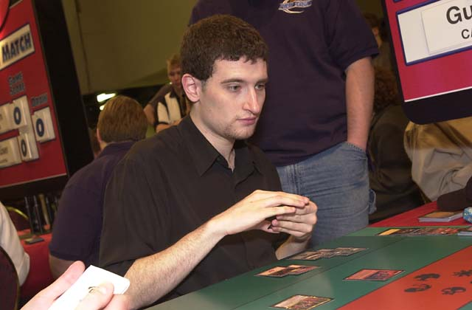
Will Jon Finkel repeat at Boston?
This is the second time a Grand Prix is to be held in the city of Boston. The first GP Boston was legendary. It featured what many consider to be the strongest Top 8 at any Grand Prix, ever. Top 8 was as follows:
- Jon Finkel
- Randy Buehler
- Steven O'Mahoney-Schwartz
- Zvi Mowshowitz
- Darwin Kastle
- Mike Bregoli
- Matthew Calhoun
- Ben Farkas
Jon Finkel set one of his many records by going undefeated through the entire tournament. He refused to intentionally draw against Zvi Mowshowitz in the final round of Swiss, defeating him. Finals between two of the finest players in the game were worth watching as well.
On a more personal note, I lost the last round to Ben Farkas, ended up 13th - which was the last place to receive an invitation to Pro Tour - Rome. That was the turning point in my Magic career - I've stayed on the Pro Tour ever since.
Understandably, I am looking forward to this Grand Prix. Just about everyone I talked to who attended it in 1998 has warm memories of the tournament. Of course, few of us are as excited about it as the Boston players. Boston is arguably the best city in the world to live in for a Magic player. It boasts a high concentration of pros - team YMG is located there, Brian Kibler, William Jensen, Steve OMS, Bruce Cowley, Mike Bregoli are just few of the names who play there regularly.
Grand Prix: Boston this weekend will be the first major North American tournament to include Planeshift.

COMING UP: GRAND PRIX COLOGNE
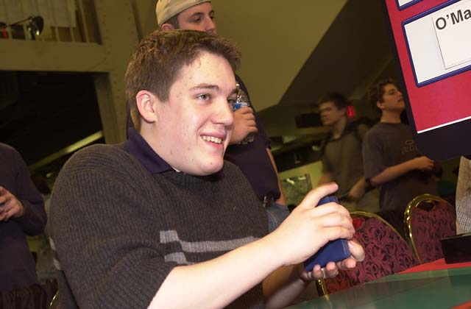
At the same time when many North American pros will be vying for top prize in the City of Clam Chowdah, European players will travel to Germany to attend Grand Prix: Cologne (or Koln, as the city is called in German).
Cologne is home to some of Germany's finest. Kai Budde, Dirk Baberowksi, Frank Adler and Andre Konstanczer have all lived and played there at one point or another.
One of the greatest attractions of this tournament is that it falls on the same weekend as Carnival. Many people will be traveling to Cologne for a weekend of celebrating and drinking. Although it will inconvenience some Magic players, since lodging is pretty hard to find for this weekend, it will certainly make missing Day 2 a lot less painful

MAGIC TRIVIA

Last week's question:
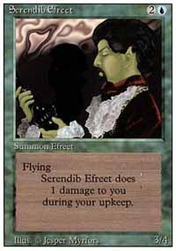
What card appears misprinted more than it appears in its corrected version?

Answer:
Serendib Efreet. A version of Serendib Efreet printed in Revised Edition had incorrect artwork (Iff-Biff Efreet's), and Revised print run is much larger than that of Arabian Nights.

New Question:
Courtesy of Phil Shenandoah:
You only play one creature in an entire game. Your opponent has absolutely no defensive measures, so he takes full damage from the creature every time you attack with it. Assuming nothing is done to alter the creature's power, the damage dealt, or your opponent's life total, and that it is the only source of damage against your opponent that you play, what creature deals game-winning (at least 20) combat damage in exactly eight turns after it is played?
Please do not e-mail me with your answers. There is no prize, this is strictly for fun. Correct answer will be posted in the next week's column.

BEST OF THE NET
Let's talk tournament reports. Pretty much all of Magic internet strategy grew out of a few people posting their tournament experiences on the newsgroups. Even today, tournament reports are among the most interesting articles posted on the independent Magic web sites. Here are a few of the best reports posted this week.
On Meridian Magic, you will find a Pro Tour: LA report by Brian Kibler. Mindripper is hosting an LA report by Kai Budde. On Star City, you can read a highly entertaining report about a Type 1 tournament, by Geordie Tait.

BAD PLAY OF THE WEEK
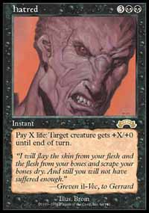
Courtesy of Joel Hinz:
At a Type 1 side-event at Gothcon (Swedish convention) last year, I saw a guy winning his first two matches and coming to play the final. In the first game, he felt sure of winning as he got quite a broken start, and on turn two he cast Demonic Consultation, naming Necropotence. Guess that would have been an excellent play if he was playing Trix, the problem was that he should have searched for a Hatred as he was playing Suicide
Seems like sleep isn't just a substitute for consciousness. And oh, that stupid player, it was me... and I proceeded to lose that match.
As always, please send good/bad plays, cool trivia questions, and other news to ashv@concentric.net.

